Charging pile installation manual
- Preparation for installation
Prepare the following tools: Phillips screwdriver, wire stripper, adjustable wrench, hammer, screws, electric drill, electrical glue, and 12 bit
- Safety Precautions
Read this instruction carefully before installation, operation, maintenance or inspection.
As electronics, touching live parts can be dangerous. And the ac side voltage of the product can reach 220V.

 | Warning: Ensure that the charging pile is not charged before operation and installation.
 | Note: this device must be installed by a professional electrician.

Directions for use
- Read the manual in detail before using the project.
- The device has to be installed by a professional.
- To protect your safety, you have to spend time installing something by grounding it properly.
- Gigonists should not operate in high humidity or temperature, volatile gases or flammable environments;
- Buying a ticket bans overload to avoid power failures;
- Buying a machine should be handled with care;
- Arrange to open the package and check the attachments. If you find missing parts or damage during transportation, please contact asap and you will get satisfactory service.

If the equipment is damaged due to failure to install according to the instructions in this manual, the company reserves the right not to guarantee the quality.
- Install the wiring
3.1 wiring:
- Open the back cover of the whole pile, and put the feed line into the waterproof apron and into the control box.
- Incoming line access according to the mark of the control board, l-IN, N-IN, PE (as shown IN Figure 1).
- Loosen the screws on the combined wiring terminals with a flat-head screwdriver, insert the connectors of the cables into the wiring terminals one by one, and lock them tightly with a Phillips screwdriver.
- And then the waterproof apron card, close the back cover can be.

Note: this product has its own leakage protection function, according to the national requirements of high-power electrical equipment into the end of the leakage protection should be added.

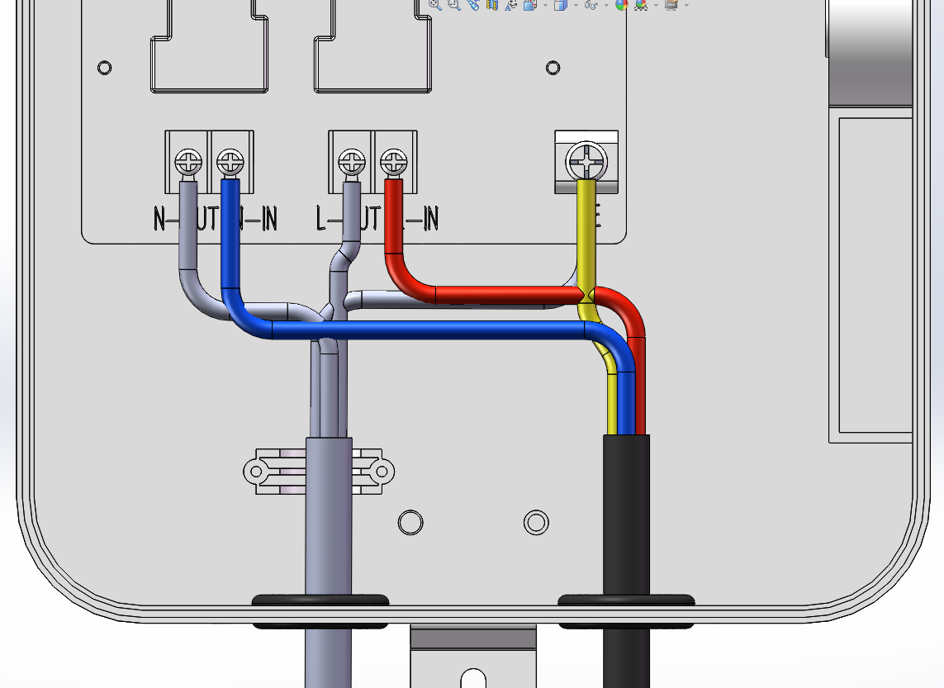
inlet wire
3.2 Wall-mounted installation
Mounting rear mounting plate :
- Positioning: select the appropriate installation position, to determine the expansion plastic pipe vacancy (note: the installation position shall not be less than 30 cm from the wall).
- Drilling; Drill three holes with a depth greater than 45mm on the wall with an 8mm drill according to the position of the fixing holes on the rear hanging plate.
- Insert the expansion plastic pipe into the hole, and parallel the plastic part with the outer edge.
- Install the hanging bar; As shown in the figure, align the hole position of the rear hanging plate with the drilled hole and tighten it with M6 flat head bolt.

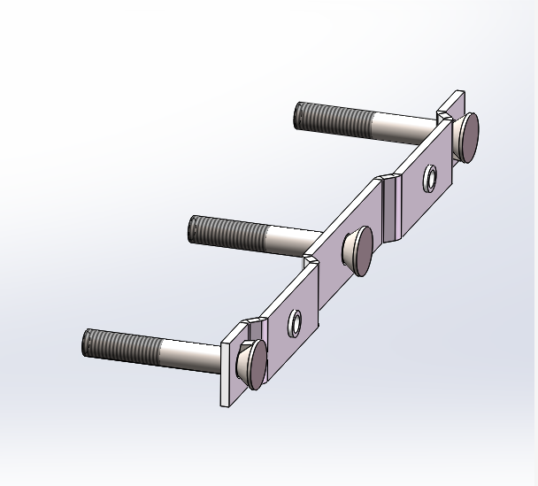
After hangs Taiwan
3.3 Whole pile installation
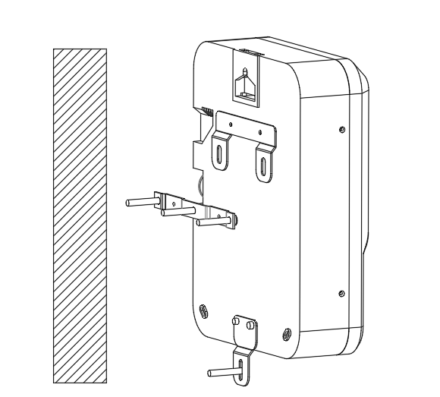
WALL

Fixed:
Install the QQ of the rear cover plate of the charging pile on the pre-installed rear hanging plate, and lock the latch with anti-theft screws.

3.4 Landing Installation
Support threading; Route the cable through the round cable inlet hole at the bottom of the support and out the cable outlet hole at the top of the support.
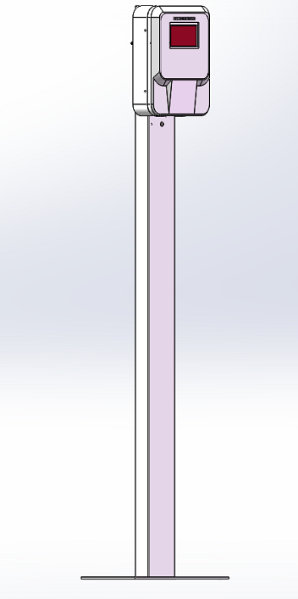

Precautions for bracket installation:
- M8 embedded bolts are used for bracket fixing.
- The embedded bolt is required to be perpendicular to the foundation surface, and the directly buried depth is greater than 150mm.
- The exposed length of the embedded bolt should ensure that 3-4 thread teeth are leaked after the nut is locked.
- Expansion bolts, hex bolts or screw rods are strictly prohibited.
- When the bracket is fixed, gaskets and spring gaskets should be added. After fixing, the bolts should be treated with anti-corrosion, and butter or silver spraying should be used.
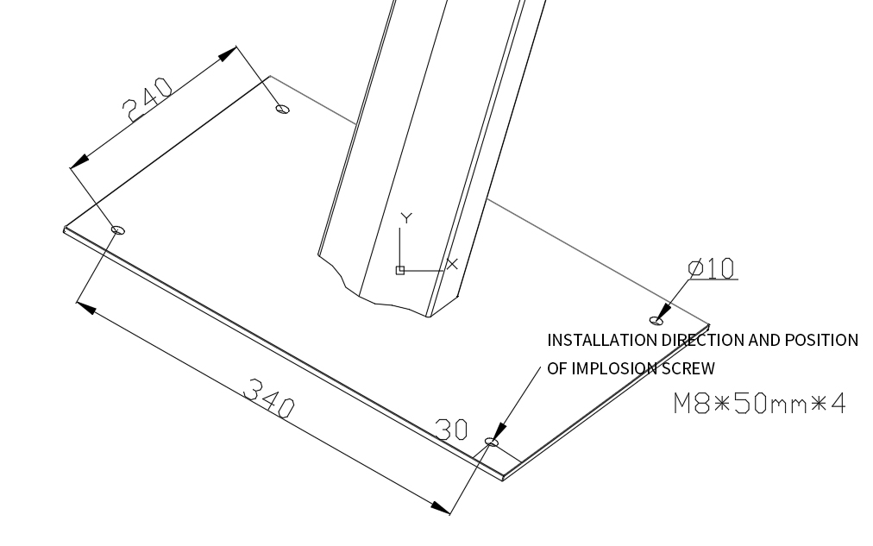

Support cover plate installation; Cover the two bracket cover plates on the bracket mounting plate and fix them with screws.
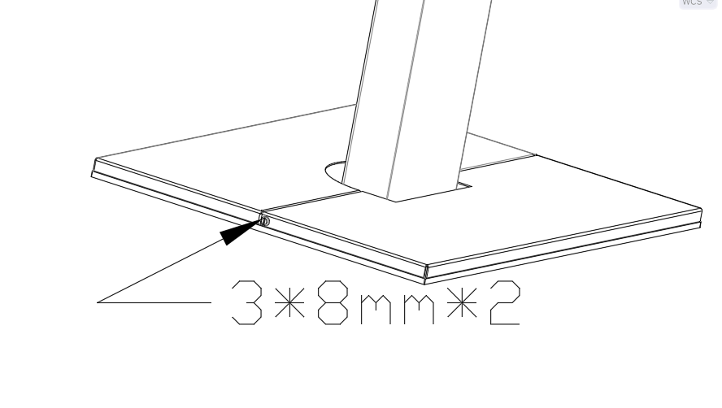
Charging pile rear hanging plate installation; Install the rear mounting plate of the charging pile on the front mounting plate of the pre-installed bracket.

